Adam Zucker
Power Pack
ECEN4013
Guidelines for Research Datasheet

I Provide a block diagram, flowchart, and/or public function headers of your block(s) for the system you will prototype in the next stage of the project.
- Label all inputs and outputs consistently.
- If required estimated external memory requirements
Total maximum current
= (100+150+250+.13+10+50)mA
= 560.13mA
Figure 1 – Team Endeavor’s Level 1 block diagram
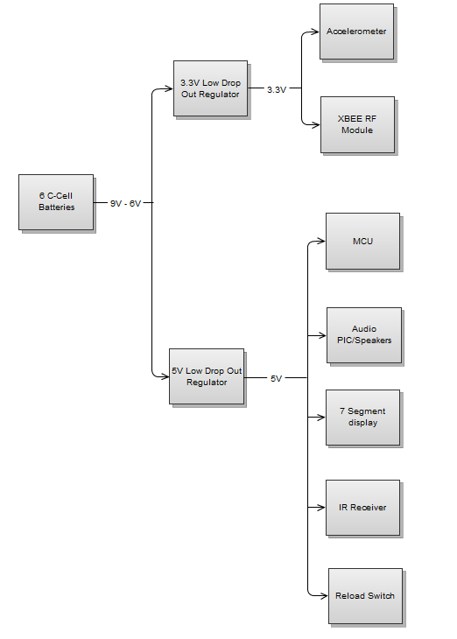
Figure 2 - Level 1 block diagram of power pack
C-Cell batteries
- With 6 batteries in series, power supply time will be 6+ hours.
  - Total weight of 6 C-cell batteries will only be 397g (14oz).
  - Same number of D-cell batteries would be 888g (31oz).
  - 16 9v batteries would be needed to provide same amount of battery capacity which would be 730g (26oz).
- Size of battery pack will be approximately 6”x2”x1” (WxLxH).
  - Approximate cost of battery pack will be $12.50.
- A toggle switch on pack will be used to turn power source on and off.
  - Approximate cost of toggle switch will be $3.20.

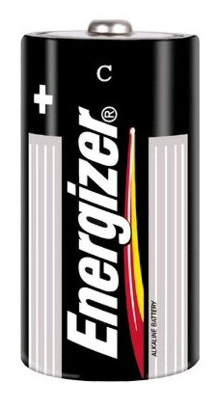
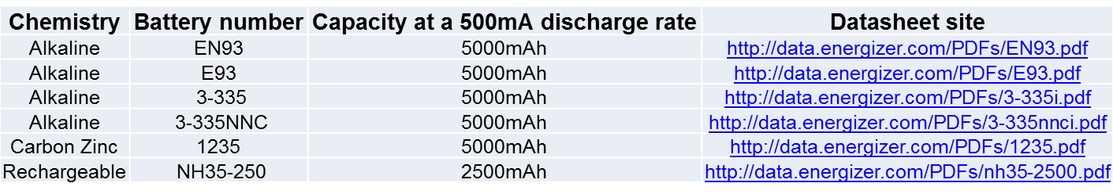
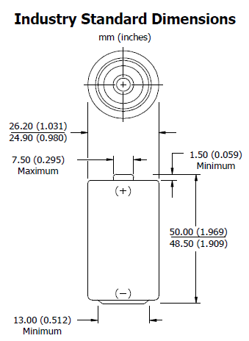
Image taken from
http://www.blasterstool.com/energizerbatteryc-cellen932pack.aspx
Typical Weight
66.2 grams
Image taken from
http://data.energizer.com/PDFs/EN93.pdf
Voltage Regulators
- Need two different supply voltages (5V and 3.3V)
- Why Low drop out (LDO) regulator as opposed to standard?
  - LDO requires less voltage to maintain output voltage regulation as opposed to standard.
  - With the 511-L4931ABD50 having a max current of 300mA, 2 will be needed.
    - One will be solely designated to power the MCU.
    - The other will be used to power the remaining components.
  - With the 511-L4931ABD33 having a max current of 300mA, only one will be needed.
- Approximate price of all three Voltage regulators will be $2.80.

5V LDO
Part Number | Minimum input voltage | Maximum current
511-L4931ABD50 | 5.8V | 300mA

3.3V LDO
Part Number | Minimum input voltage | Maximum current
511-L4931ABD33 | 4.2V | 300mA

Transfer of voltage and current from arm to shuriken
- All power components will be housed in the arm band power pack. 6 pieces of 20AWG wire will be connected from the power pack to the shuriken. There will be a sufficient amount of wire to ensure proper movement is allowed.

II Alternative Approaches
Provide block diagrams, flowcharts, and/or public function headers of the alternative approaches you considered and rejected. Describe in a short paragraph why you feel these are not viable options.

9 Volt battery source
With such a low capacity, 16 batteries would be needed in order to provide the same capacity as the C-cell batteies. With such a low capacity, the effeciency per weight is only 7mA/gram, being the lowest out of all three choices.
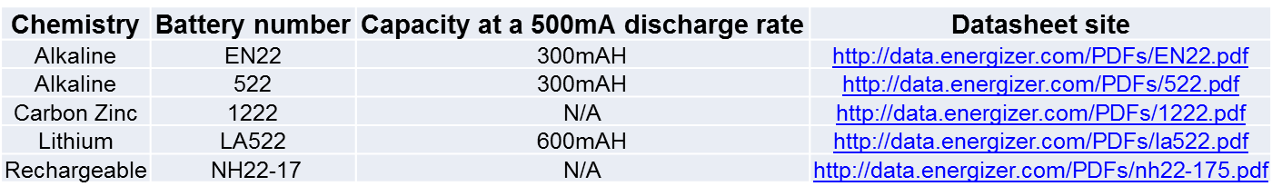
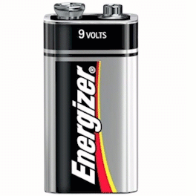
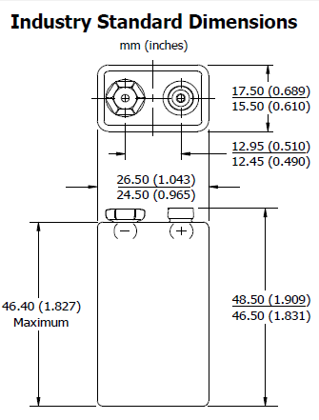
*Image taken from http://alkalinebatteries.us/Energizer_9Volt_522.html
Typical Weight
45.6 grams
*Image taken from
http://data.energizer.com/PDFs/EN22.pdf

- D - cell battery source
  - Disadvantages
    - Low supply voltage
    - Heavy
    - Low efficiency per weight (54mA/gram)

The same number of batteries would be needed in comparison to the C-Cell batteries, but the weight of each battery is more than doubled, with the capacity of the battery only increasing by a fraction. With such a high weight, the effeciency per weight is 54 mA/gram, being the 2nd lowest out of the three choices.

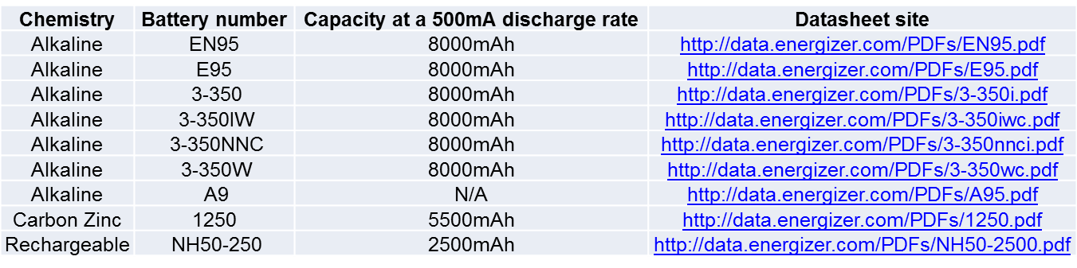
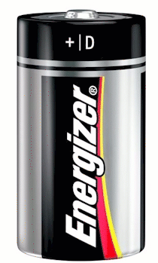
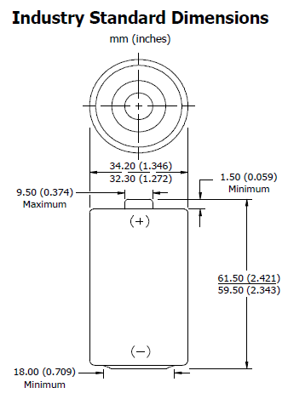
*Image taken from
http://www.electronicsnmore.com/index.php/cPath/4_92_88
Typical Weight
148.0 grams
*Image taken from
http://data.energizer.com/PDFs/EN95.pdf
Standard Voltage Regulators

The standard voltage regulators require a higher input voltage in order to be able to maintain proper voltage regulation. A problem occurs due to the fact that the batteries are discharging. With 6 C-Cell batteries, a total of 9 V will originally be supplied. With each battery dropping 500mV over an 8 hour period, the low voltage will be 6 V and the standard regulators will not be able to regulate voltage anymore. Additional batteries would be needed to keep such a robust operational time, or the possible run time will be greatly reduced.
5V Standard Regulator
Part Number | Minimum input voltage
uA78M05 | 7
μA78L00 | 7
TL780 | 7
III Data Sources
In the table below list the sources of information you used in your research. These may include websites, datasheets, books, prior code, etc. Indicate which sources you will be using in your prototype. Please bring a copy of all the data sources you found useful
Type of datasource | Title, URL, etc. | Using in Prototype?
Datasheet | http://www.ti.com/lit/ds/symlink/ua78m05.pdf | No
Datasheet | http://www.ti.com/lit/ds/symlink/ua78l05a.pdf | No
Datasheet | http://www.ti.com/lit/ds/symlink/tl780-05.pdf | No
Datasheet | http://www.st.com/internet/com/TECHNICAL_RESOURCES/TECHNICAL_LITERATURE/DATASHEET/CD00000971.pdf | Yes
Datasheet | http://www.diodes.com/datasheets/AP1117.pdf | Yes
Datasheet | http://data.energizer.com/PDFs/EN22.pdf | No
Datasheet | http://data.energizer.com/PDFs/522.pdf | No
Datasheet | http://data.energizer.com/PDFs/1222.pdf | No
Datasheet | http://data.energizer.com/PDFs/la522.pdf | No
Datasheet | http://data.energizer.com/PDFs/nh22-175.pdf | No
Datasheet | http://data.energizer.com/PDFs/EN93.pdf | No
Datasheet | http://data.energizer.com/PDFs/E93.pdf | Yes
Datasheet | http://data.energizer.com/PDFs/3-335i.pdf | No
Datasheet | http://data.energizer.com/PDFs/3-335nnci.pdf | No
Datasheet | http://data.energizer.com/PDFs/1235.pdf | No
Datasheet | http://data.energizer.com/PDFs/nh35-2500.pdf | No
Datasheet | http://data.energizer.com/PDFs/EN95.pdf | No
Datasheet | http://data.energizer.com/PDFs/E95.pdf | No
Datasheet | http://data.energizer.com/PDFs/3-350i.pdf | No
Datasheet | http://data.energizer.com/PDFs/3-350iwc.pdf | No
Datasheet | http://data.energizer.com/PDFs/3-350nnci.pdf | No
Datasheet | http://data.energizer.com/PDFs/3-350wc.pdf | No
Datasheet | http://data.energizer.com/PDFs/A95.pdf | No
Datasheet | http://data.energizer.com/PDFs/1250.pdf | No
Datasheet | http://data.energizer.com/PDFs/NH50-2500.pdf | No
Website | http://www.national.com/assets/en/appnotes/f4.pdf | Yes
Datasheet | http://www.alphawire.com/products/Wire/Hook-Up-Wire/Premium/392075.aspx?device=pdf | Yes

IV Simulation
Provide a simulation if possible or, if this is not possible, a graph or sketch of the expected inputs and outputs of your system. These should be correctly labeled and as quantitative as possible.

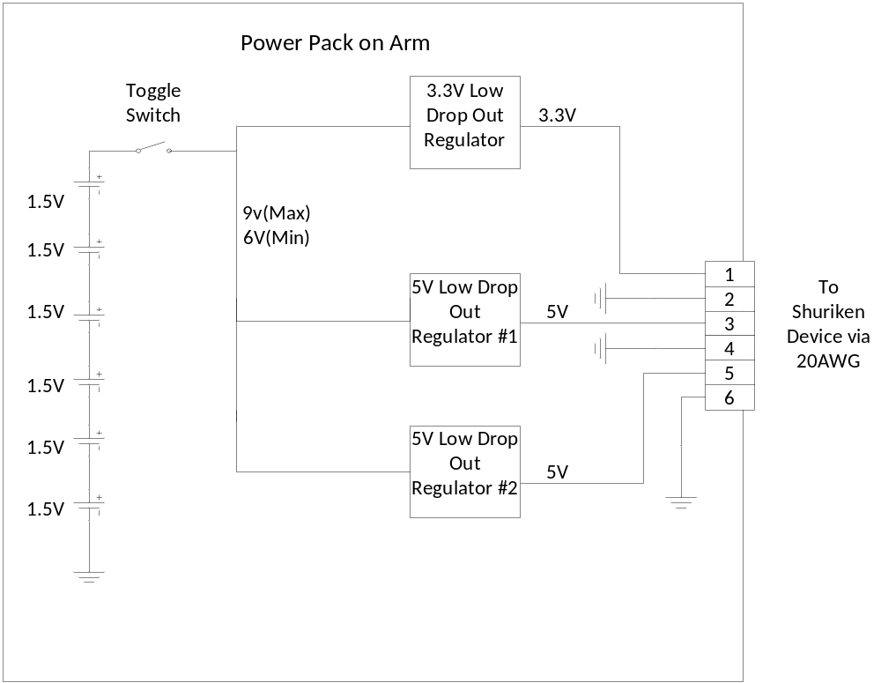
Figure 3 – Flow of power in Power Pack
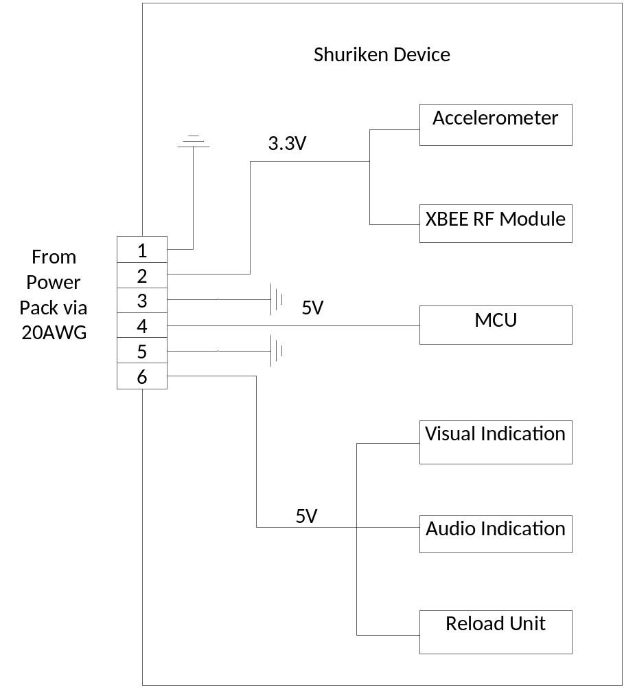
Figure 4 - flow of power on Shuriken Device

Output of batteries will be approximate 9V on full charge. Output of batteries needs to be at least 5.8V in order for all LDO’s to properly regulate voltage. If voltage is below this threshold, batteries need to be changed.

V Discussion
Be prepared for an in-depth discussion of the results of your research with the instructor and/or TAs.

Price of batteries were found at http://www.amazon.com/Energizer-Alkaline-Size-Battery-8-Count/dp/B0044DA3NS/ref=sr_1_1?ie=UTF8&qid=1318388169&sr=8-1
Price of switch was found at http://www.radioshack.com/product/index.jsp?productId=2062512
Information found on http://www.national.com/assets/en/appnotes/f4.pdf
Price found on http://www.mouser.com/Search/Refine.aspx?Keyword=511-L4931ABD33

